Arrays in Java
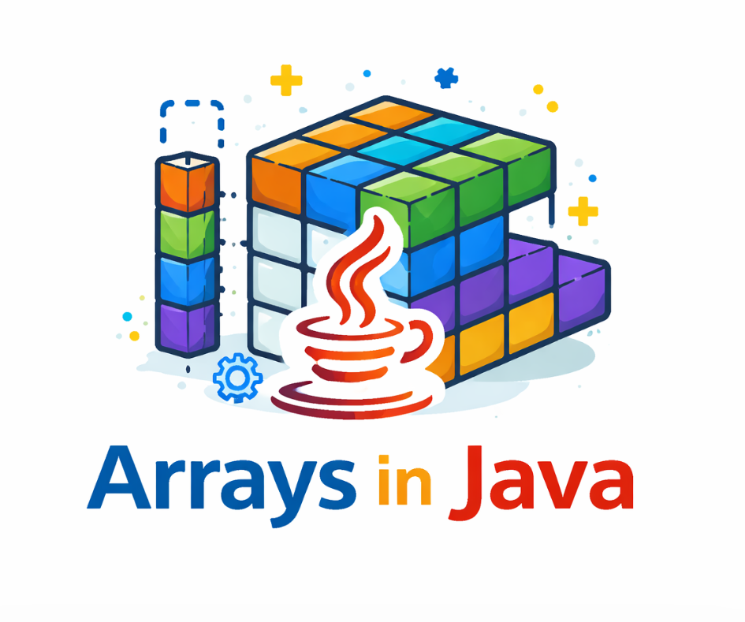

What is Array ?
An array is a collection of elements of the same data type stored in contiguous memory locations. It allows multiple values to be stored under a single name and accessed using an index.

- Java arrays can hold both primitive types (like int, char, boolean, etc.) and objects (like String, Integer, etc.)
- When we use arrays of primitive types, the elements are stored in contiguous locations. For non primitive types, references to items are stored at contiguous locations.
- The first element of the array is at index 0.
- After creating an array, its size is fixed; we can not change it.

Example
public class Array{

public static void main(String[] args){

// Primitive array
int[] arr = {10, 20, 30, 40};
int n = arr.length;

System.out.print("Primitive Array -> ");
for (int i = 0; i < n; i++)
System.out.print(arr[i] + " ");

System.out.println();

// Non-primitive array (String objects)
String[] names = {"Lakshit", "Rahul", "Pankaj"};

System.out.print("Non-Primitive Array -> ");
for (int i = 0; i < names.length; i++)
System.out.print(names[i] + " ");
}
}

Output
Primitive Array -> 10 20 30 40
Non-Primitive Array -> Lakshit Rahul Pankaj

Explanation:
- The primitive array stores integer values and is traversed using a loop.
- The non-primitive array stores String objects and is printed in the same way using its length property.

Primitive Array :

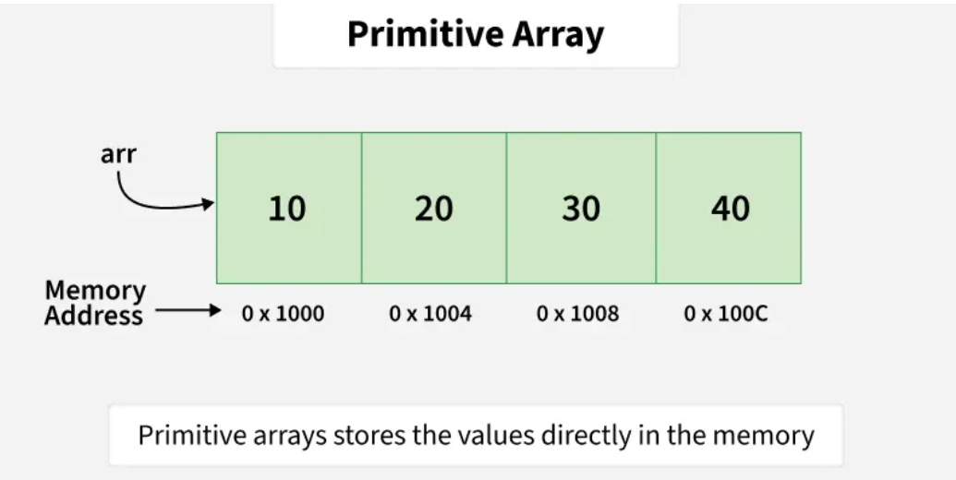

Example of Primitive Array
int[] arr = {10, 20, 30, 40};
Here:
- int = primitive data type
- So this is a primitive array

More Examples
Integer Array
int[] numbers = {1, 2, 3, 4};

Double Array
double[] prices = {99.5, 49.9, 10.0};

Character Array
char[] letters = {'A', 'B', 'C'};

Boolean Array
boolean[] flags = {true, false, true};

How Primitive Array Works (Important)
Primitive arrays store actual values, not references
Stored in continuous memory
Fast access using index
Default values are assigned automatically

Example: Default Values
int[] arr = new int[3];
System.out.println(arr[0]); // 0
System.out.println(arr[1]); // 0
System.out.println(arr[2]); // 0

Traversing Primitive Array
int[] arr = {10, 20, 30};
for(int i = 0; i < arr.length; i++) {
System.out.println(arr[i]);
}

For-Each Loop (Best Practice)
for(int num : arr) {
System.out.println(num);
}
Non Primitive Array :-

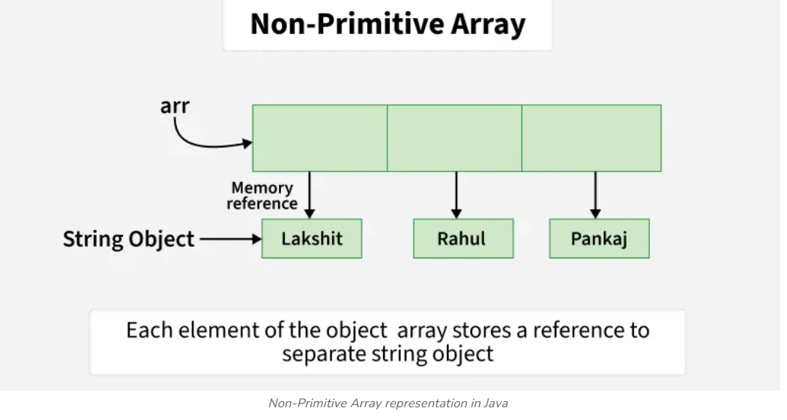

What is a Non-Primitive Array?
A non-primitive array is an array that stores objects (references) instead of actual values.
Means:
- It stores address (reference) of objects
- Not the actual data directly

Examples of Non-Primitive Types
String
Arrays
Classes (like Student, Employee)
Interfaces

Example: String Array
String[] names = {"Omii", "Rahul", "Amit"};
Here:
- String is non-primitive
- So this is a non-primitive array

How It Works (Important Concept)
In primitive array:
- Values stored directly → 10, 20, 30
In non-primitive array:
- References stored → address of objects in memory
Simple understanding:
- Primitive → value
- Non-primitive → reference

Example Using Objects (Very Important 🔥)
Step 1: Create Class
class Student {
int id;
String name;
}

Step 2: Create Array of Objects
public class Test {
public static void main(String[] args) {
Student[] students = new Student[2];
students[0] = new Student();
students[1] = new Student();
students[0].id = 1;
students[0].name = "Omii";
students[1].id = 2;
students[1].name = "Rahul";
System.out.println(students[0].name);
System.out.println(students[1].name);
}
}

Default Values (Very Important 🔥)
In non-primitive arrays:
- Default value = null
String[] arr = new String[3];
System.out.println(arr[0]); // null

Traversing Non-Primitive Array
String[] names = {"Omii", "Rahul", "Amit"};
for(String name : names) {
System.out.println(name);
}

Declaring an Array
In Java, an array is declared by specifying the data type, followed by the array name, and empty square brackets [].
dataType[] arrayName;
or
dataType arrayName[];

Initialization an Array
When an array is declared, only a reference is created. Memory is allocated using the new keyword by specifying the array size.
int arr[] = new int[size];
- Once an array is created, its size is fixed and cannot be changed. For collections that can grow or shrink dynamically, Java provides classes like ArrayList or Vector.
- Memory for arrays is always allocated on the heap in Java.
- The elements in the array allocated by new will automatically be initialized to zero (for numeric types), false (for boolean) or null (for reference types).

Initialization using Array Literal
You can use array literals to initialize an array when declaring it. In this case, the new keyword is not required-
Example:
int[] arr = {1, 2, 3};

- The length of this array determines the length of the created array.
- There is no need to write the new int[] part in the latest versions of Java.

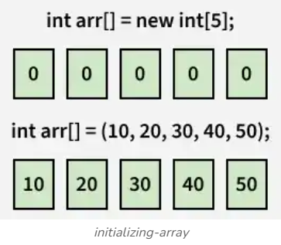

Operations on Array Elements

1. Access Array Elements
Elements of an array can be accessed by their position, called the index. In Java, array indexing starts from 0 (not 1). To access an element, provide the index inside square brackets [] along with the array name.

class Access{

public static void main(String[] args){

int[] arr = {2, 4, 8, 12, 16};

// Accessing fourth element
System.out.print(arr[3] + " ");

// Accessing first element
System.out.print(arr[0]);
}
}

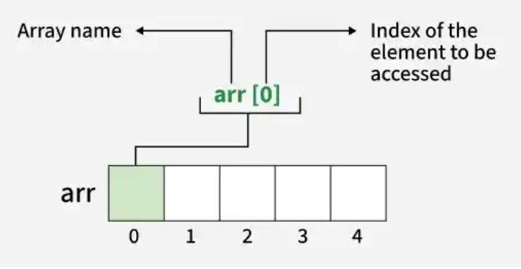
2. Update Array Elements
To update an element at a specific index in an array, use the assignment operator = while accessing the array element and assign a new value.

class Array{

public static void main(String[] args){

int[] arr = {2, 4, 8, 12, 16};

// Updating first element
arr[0] = 90;
System.out.println(arr[0]);
}
}
Output :
90

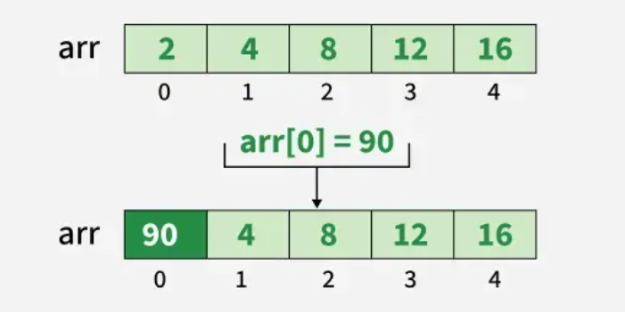

3. Traverse Array
Traversing an array means accessing each element one by one. In Java, arrays can be easily traversed using a loop where the loop variable runs from 0 to array.length - 1.

class Array{

public static void main(String[] args){

int[] arr = {2, 4, 8, 12, 16};

// Traversing and printing array
for (int i = 0; i < arr.length; i++) {
System.out.print(arr[i] + " ");
}
}
}

Output
2 4 8 12 16

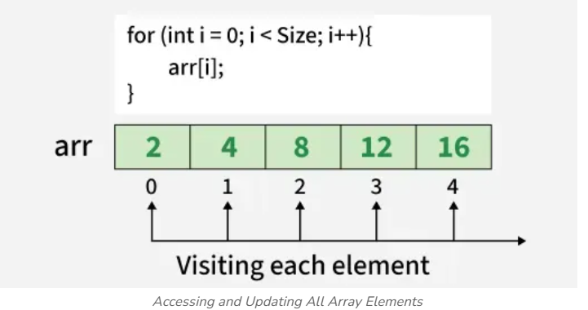
4. Size of Array :
The size of an array refers to the number of elements it can hold. To find the size of array java provides a built-in property called length.

class GFG{

public static void main(String[] args){

int[] arr = {2, 4, 8, 12, 16};
System.out.println("Size of array: " + arr.length);
}
}

Output
Size of array: 5

Arrays of Objects in Java
An array of objects is created like an array of primitive-type data items

Example: Create an array of five Student objects by instantiating each Student using its constructor and storing their references in the array.

class Student {
public int roll_no;
public String name;

Student(int roll_no, String name){
this.roll_no = roll_no;
this.name = name;
}
}

public class Array {
public static void main(String[] args){

// declares an Array of Student
Student[] arr;

// allocating memory for 5 objects of type Student.
arr = new Student[5];

// initialize the elements of the array
arr[0] = new Student(1, "aman");
arr[1] = new Student(2, "vaibhav");
arr[2] = new Student(3, "shikar");
arr[3] = new Student(4, "dharmesh");
arr[4] = new Student(5, "mohit");

// accessing the elements of the specified array
for (int i = 0; i < arr.length; i++)
System.out.println("Element at " + i + " : { "
+ arr[i].roll_no + " "
+ arr[i].name+" }");
}
}

Output
Element at 0 : { 1 aman }
Element at 1 : { 2 vaibhav }
Element at 2 : { 3 shikar }
Element at 3 : { 4 dharmesh }
Element at 4 : { 5 mohit }

What happens if we try to access elements outside the array size?
JVM throws ArrayIndexOutOfBoundsException to indicate that the array has been accessed with an illegal index. The index is either negative or greater than or equal to the size of an array.

public class Array {
public static void main(String[] args)
{
int[] arr = new int[4];
arr[0] = 10;
arr[1] = 20;
arr[2] = 30;
arr[3] = 40;

System.out.println(
"Trying to access element outside the size of array");
System.out.println(arr[5]);
}
}

Output:
Exception in thread ‘main’ java.lang. ArrayIndexOutOfBoundsException create breakpoint : Index 5 out of bounds for length 4 at Array.main(Array.java:14)

Passing Arrays to Methods
Like variables, we can also pass arrays to methods. For example, the below program passes the array to method sum to calculate the sum of the array's values.

public class Array{
// Driver method
public static void main(String args[])
{
int arr[] = { 3, 1, 2, 5, 4 };

// passing array to method m1
sum(arr);
}

public static void sum(int[] arr)
{
// getting sum of array values
int sum = 0;

for (int i = 0; i < arr.length; i++)
sum += arr[i];

System.out.println("sum of array values : " + sum);
}
}

Output
sum of array values : 15
Explanation
- This Java program demonstrates how to pass an array to a method.
- An integer array arr is declared and initialized in the main method.
- The sum() method is called with arr as an argument.
- Inside the sum() method, all array elements are added using a for loop.
- The final sum is then printed to the console.

Returning Arrays from Methods :
As usual, a method can also return an array. For example, the below program returns an array from method m1.

class Array {
// Driver method
public static void main(String args[])
{
int arr[] = m1();

for (int i = 0; i < arr.length; i++)
System.out.print(arr[i] + " ");
}

public static int[] m1()
{
// returning array
return new int[] { 1, 2, 3 };
}
}

Output
1 2 3

Advantages of Java Arrays
- Efficient Access: Accessing an element by its index is fast and has constant time complexity, O(1).
- Memory Management: Arrays have fixed size, which makes memory management straightforward and predictable.
- Data Organization: Arrays help organize data in a structured manner, making it easier to manage related elements.

Disadvantages of Java Arrays
- Fixed Size: Once an array is created, its size cannot be changed, which can lead to memory waste if the size is overestimated or insufficient storage if underestimated.
- Type Homogeneity: Arrays can only store elements of the same data type, which may require additional handling for mixed types of data.
- Insertion and Deletion: Inserting or deleting elements, especially in the middle of an array, can be costly as it may require shifting elements.

